Creating a Fabric App - Guide
Simple way to create Fabric App by using a premade reusable visual template.
https://github.com/naylaidsmed/fabric-app-template

Example:
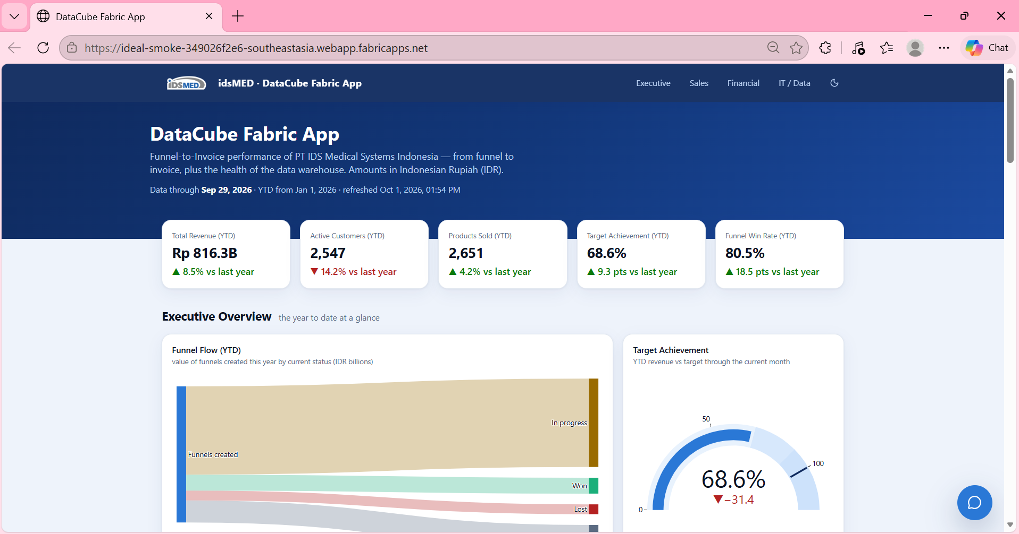

Contents
Requirements 3
A. Create Fabric App 3
B. Create Visuals (using template) 8
B2. Assign the data by yourself (self-service) 15
1. Principle 15
2. Method A – sample-data.ts 15
3. Method B – warehouse Fabric 16
4. Data type per chart 20
5. Add new table/entity 21
6. Scheduling refresh data 21
C. Publish & Commit GitHub 23
1. Check before publishing 23
2. Publish to Fabric — `npx rayfin up` 23
3. Move / add a target workspace 24
4. Save to GitHub 24
5. Rollback (return to a previous version) 24
D. Data Agent 24
1. Create a data agent in the workspace — + New item → Data agent 24
2. Choose the data source 25
3. Agent instructions 25
4. Data source instructions — explain the contents of each table & its important columns 26
5. Example queries — question + correct-SQL pairs 27
6. Test in the chat panel 27
7. Publish 28
8. (Advanced) Integrate into the app 29
Troubleshooting 29

Requirements
- Microsoft Fabric Access
Role: Contributor or more in the intended workspace (to create item, data agent, warehouse table, etc).
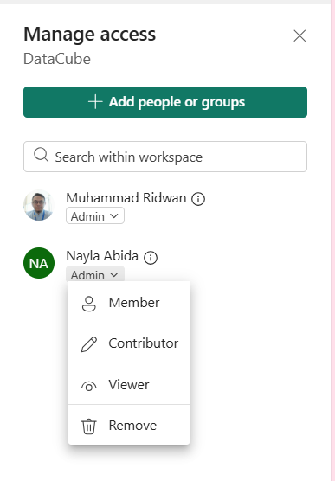

- Node.js
Version: 20
How to check: open command prompt and type node –version and enter.
Download: https://nodejs.org/en/download

- Visual Studio Code + terminal

- Git
Download: https://git-scm.com/install/windows

- Github Account
https://github.com/

A. Create Fabric App
- Create new fabric app in the workspace.
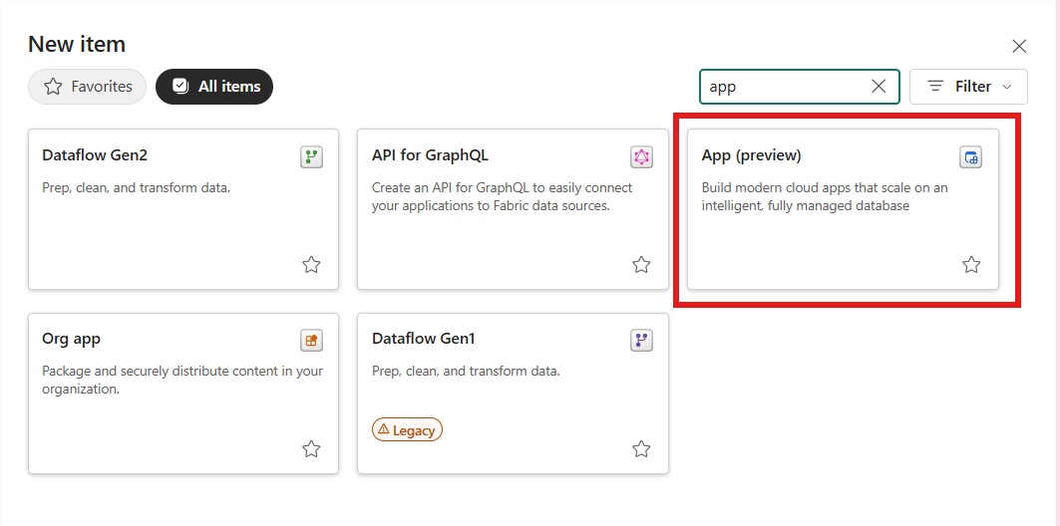

- Fill the name.
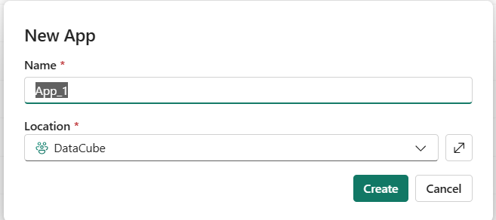

- Choose blank app. Now you have blank app.
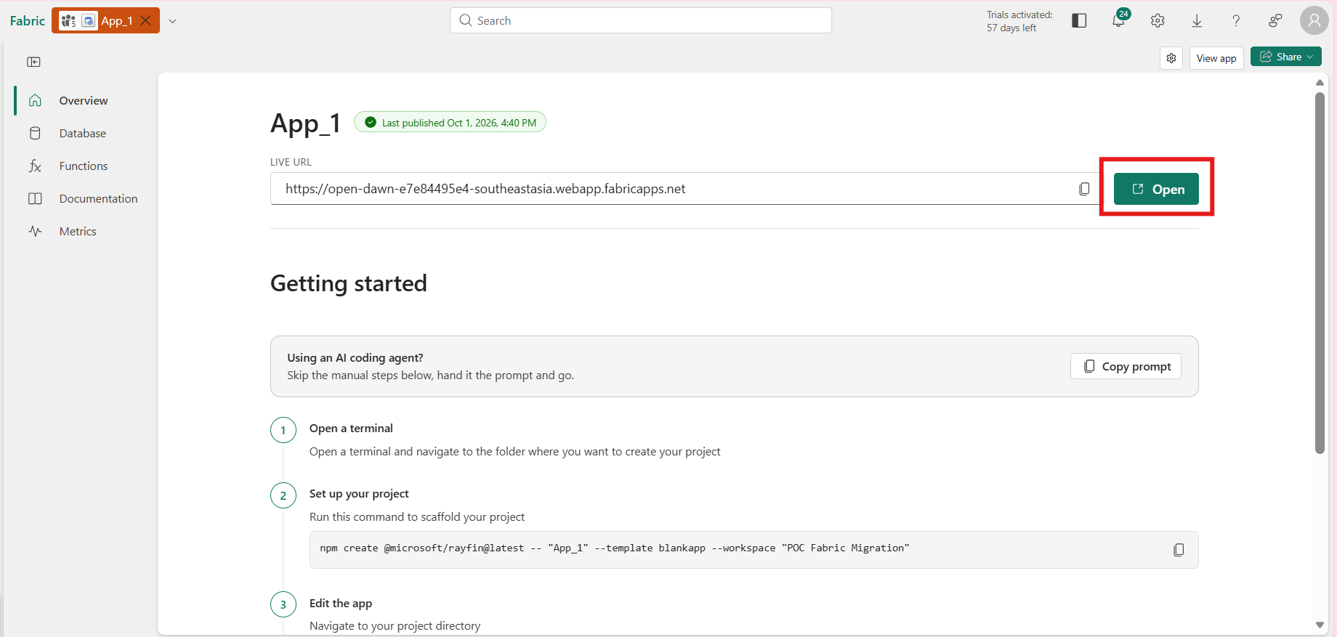
Click open and sign in to continue, that’s your Fabric App, still empty.

- Back to overview from the fabric app, follow the Getting started steps.
- Open Visual Studio Code and open folder in your preferred location.
- Set up your project, follow the step 2.
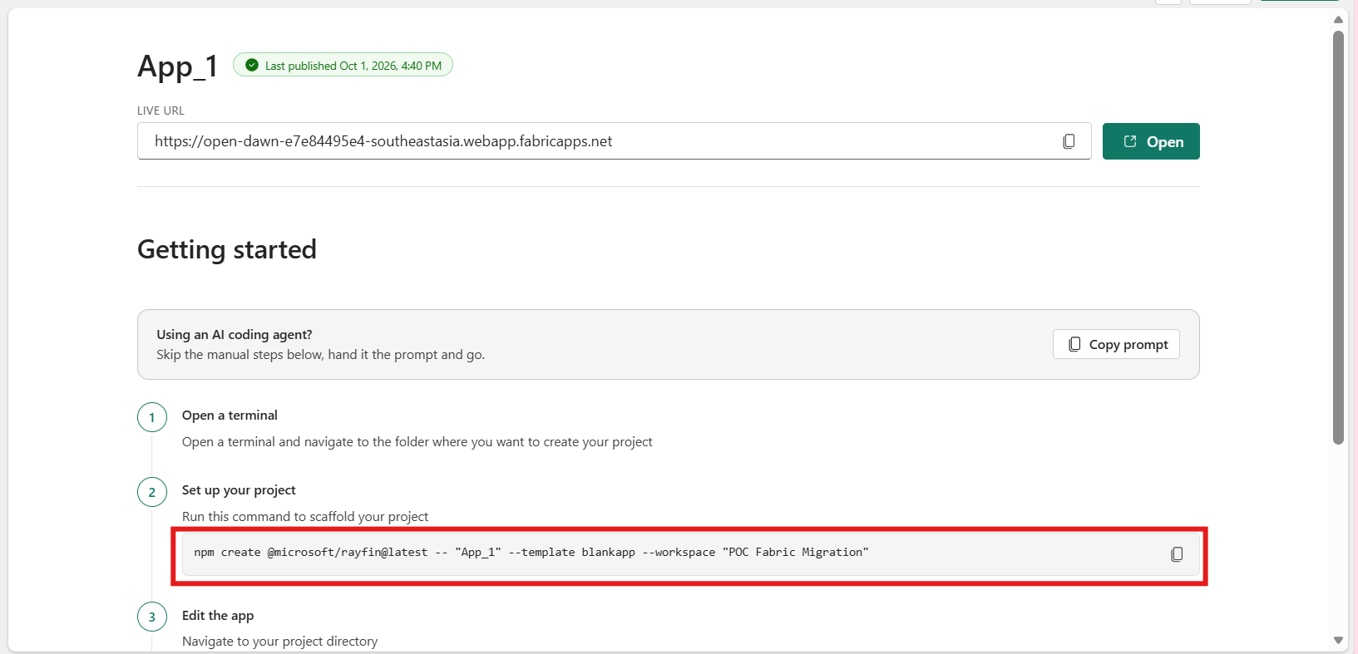
In the terminal type npm create @microsoft/rayfin@latest -- "your-app-name" --template blankapp --workspace "your-workspace-name" and enter.
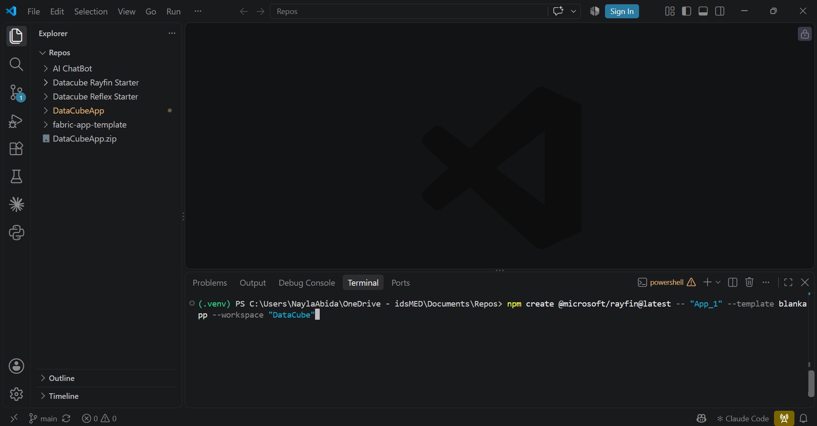

- In the terminal, proceed the installation process by typing “y” and enter.
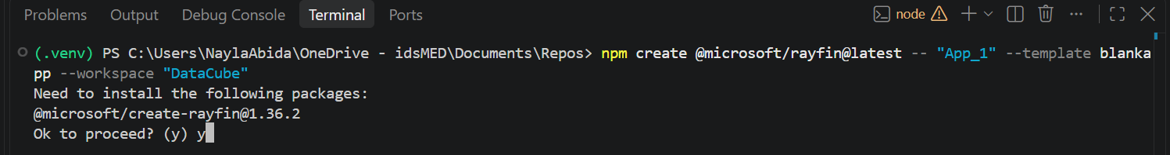
Wait until the process is finished.
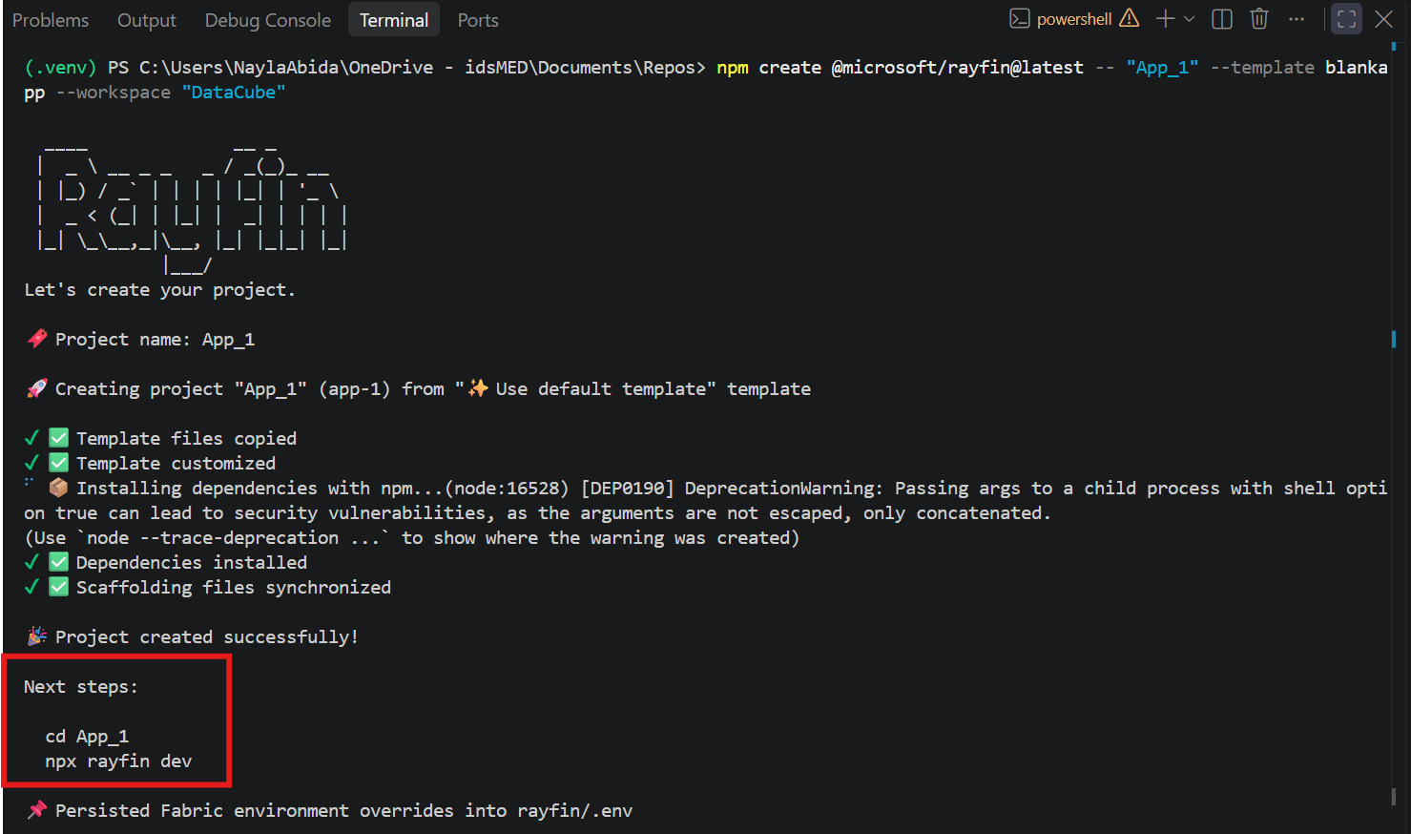
Follow the next steps

- Change directory in the terminal, and run the app by typing cd your-app-name enter and type typing npx rayfin dev or npm run dev enter.
There would be questions in the terminal for your fabric app.
- Choose a Fabric workspace for this deployment: Choose 2, select existing workspace, enter.
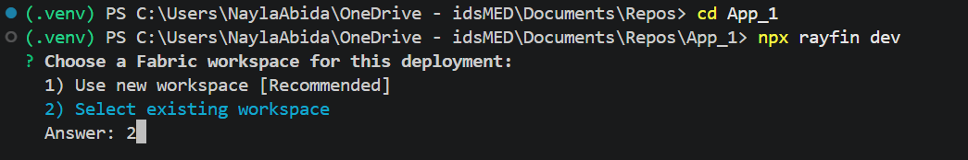

- Which Fabric workspace should be the backend live in? Use up/down arrow to choose the workspace, enter.
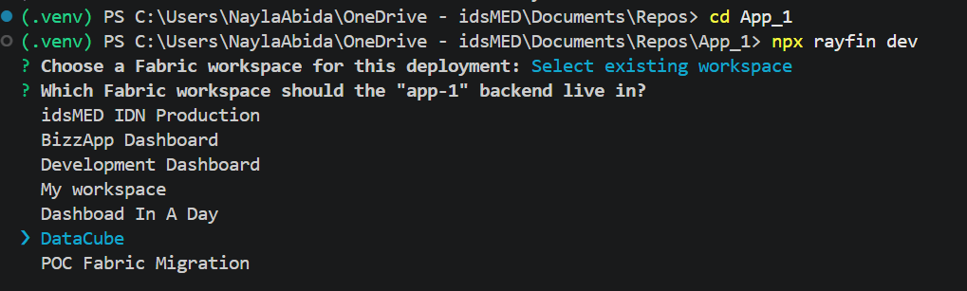

- Your app is running locally, open the url in a browser.
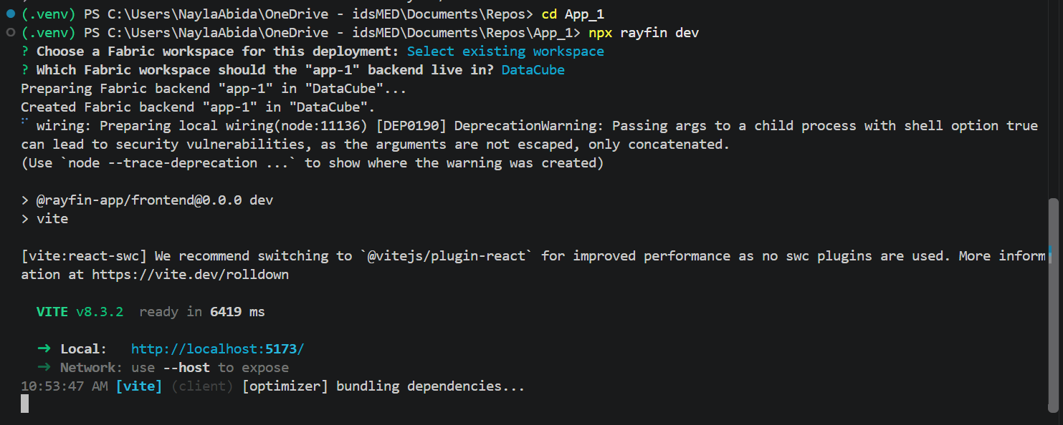

- This is what your app look like right now
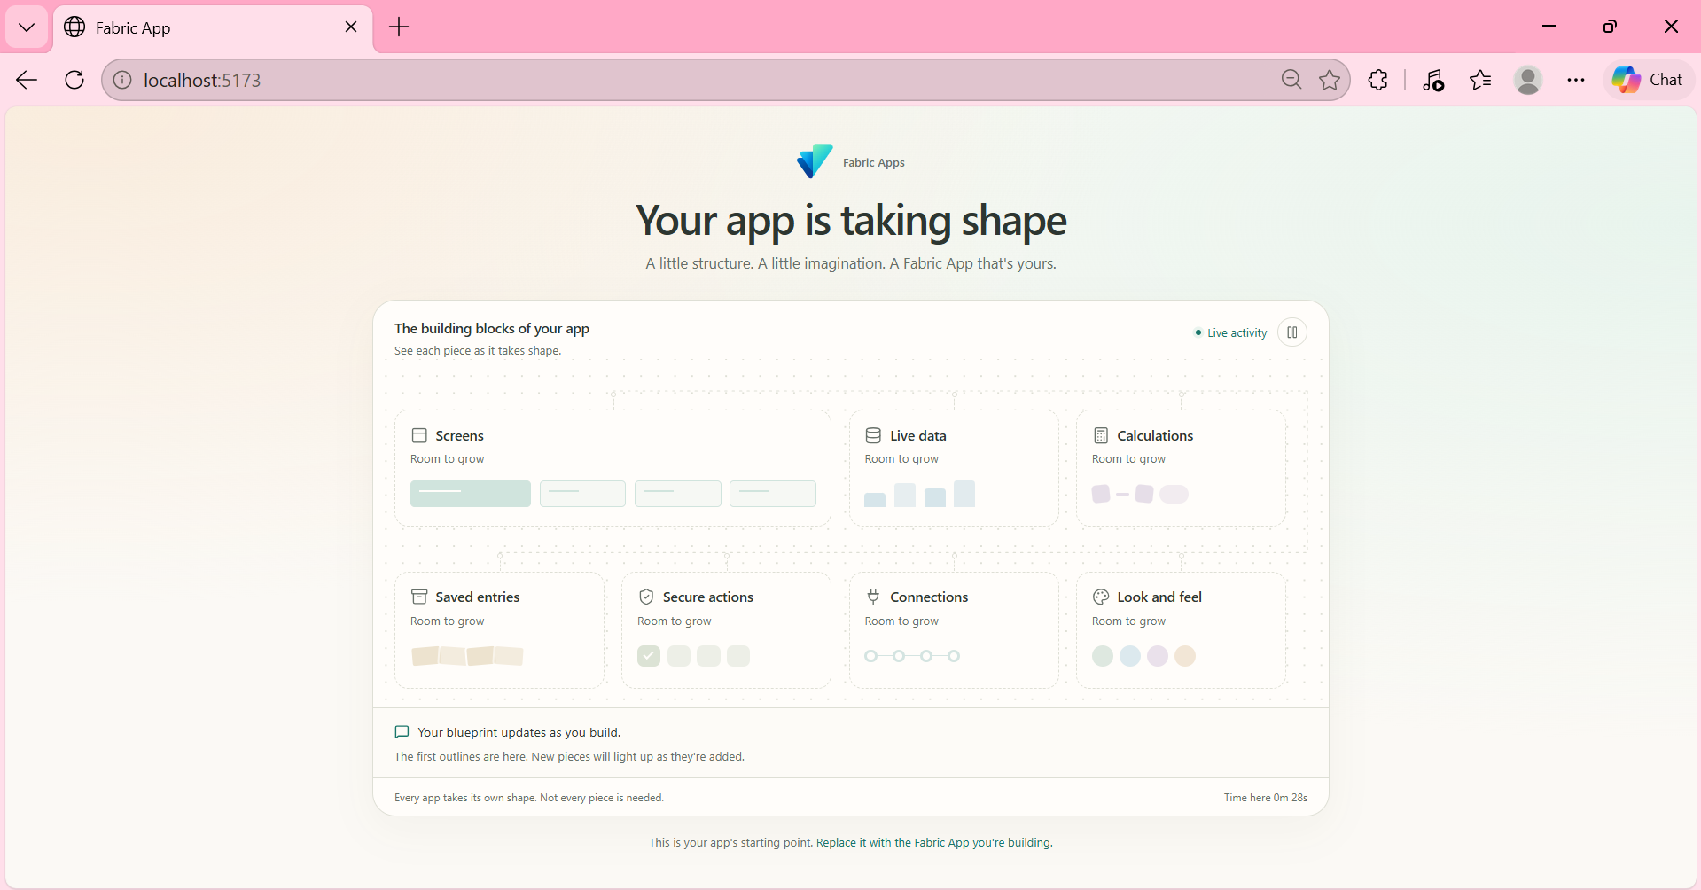

- Back to VS Code. This is your Fabric App project folder structure.
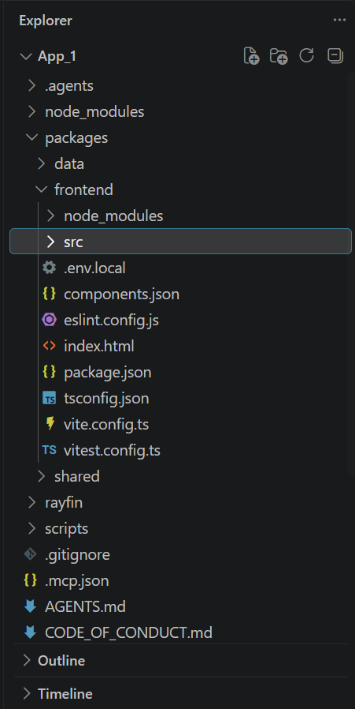
Packages/frontend/src = frontend (will be filled with templates)
Rayfin/rayfin.yml = app settings in Fabrc (auth, hosting, connector)

- After warehouse connector is added, do not use npx rayfin dev or npm run dev. Use npm run dev:frontend. Look at Troubleshooting for more details.
- Control + C to stop running.

B. Create Visuals (using template)
- Open template repository at https://github.com/naylaidsmed/fabric-app-template and download as zip. Extract it.
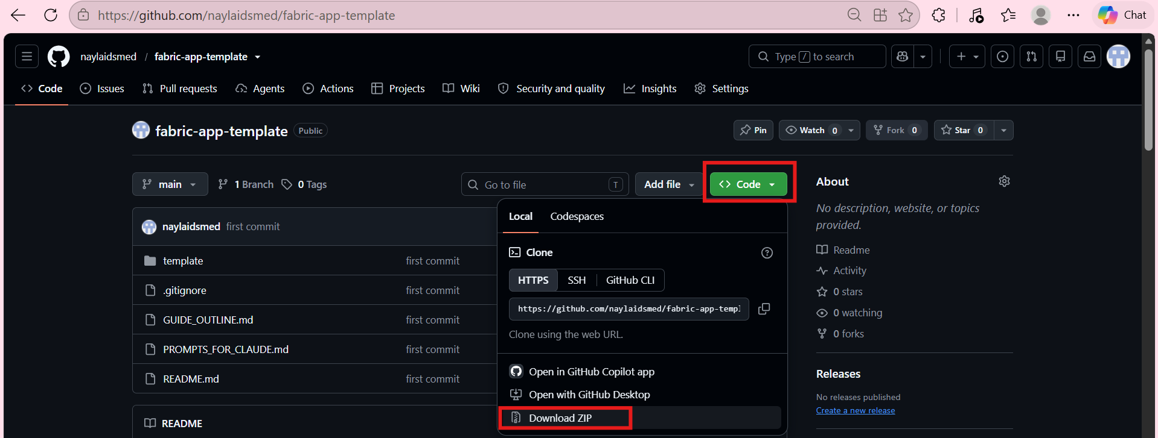
Or you can copy the content directly from the page.

- Install required library chart (Plotly) by insert these in the terminal
npm install plotly.js-dist-min@^4.1.1 -w @rayfin-app/frontend
npm install -D @types/plotly.js@^3.0.14 -w @rayfin-app/frontend
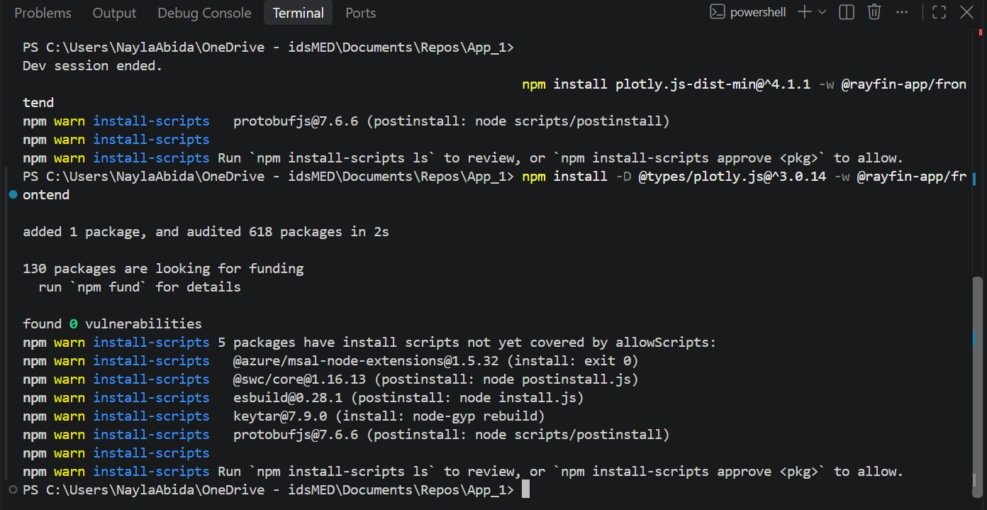

- Copy all files from template/src to packages/frontend/src overwrite App.tsx, App.spec.tsx, Root.spec.tsx, global.css
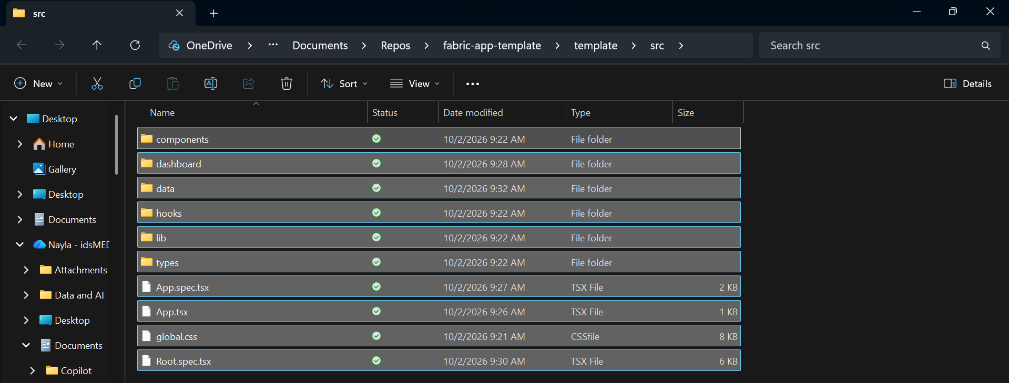

Before and after
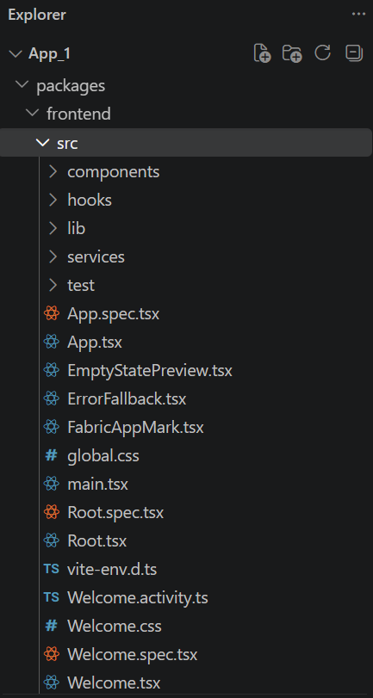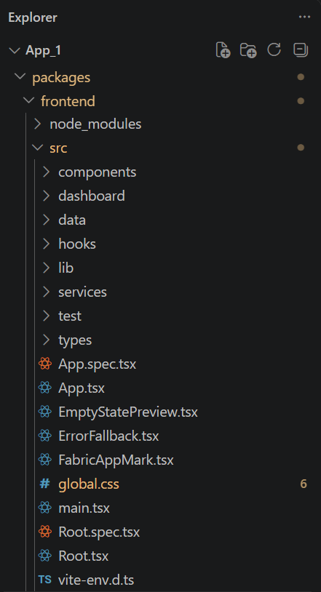

- Change title and menu at src/dashboard/Dashboard.tsx in CONFIGURATION
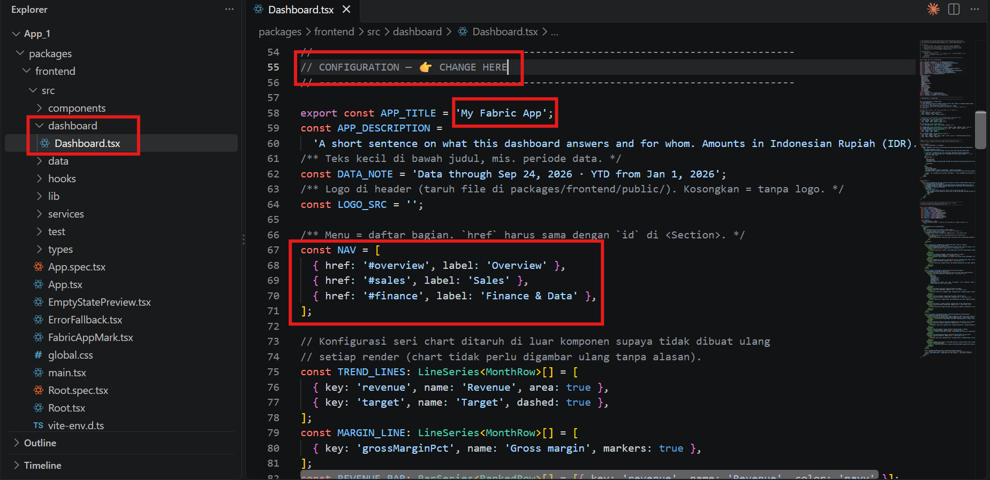
You can also add logo by creating a new folder named public inside frontend folder and insert your photo (png) there.
In the same section with the title, in line const LOGO_SRC = ‘’; add the logo’s path
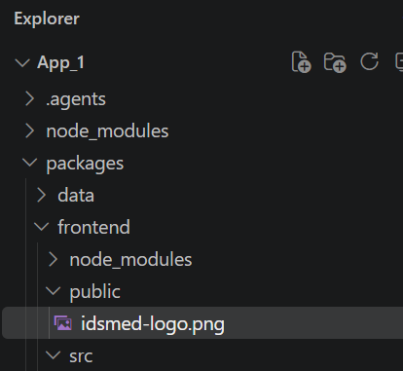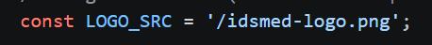

- Run with npm run dev:frontend to see your fabric app.
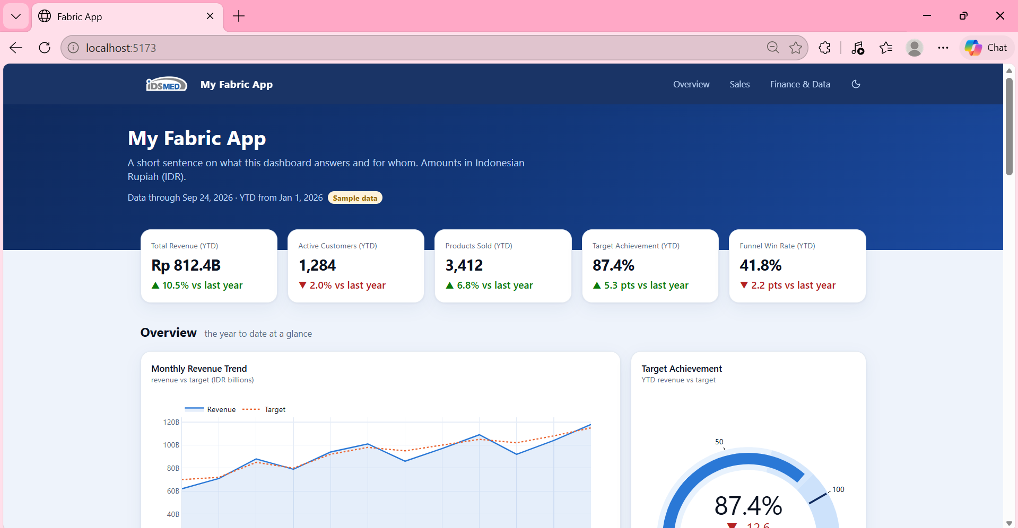
Your fabric app is looks fully done, but it’s using sample data, as stated in the dashboard.

- Choose charts you want to use
Delete unnecessary <ChartCard>, copy one to add more. Let’s try by adding one more.
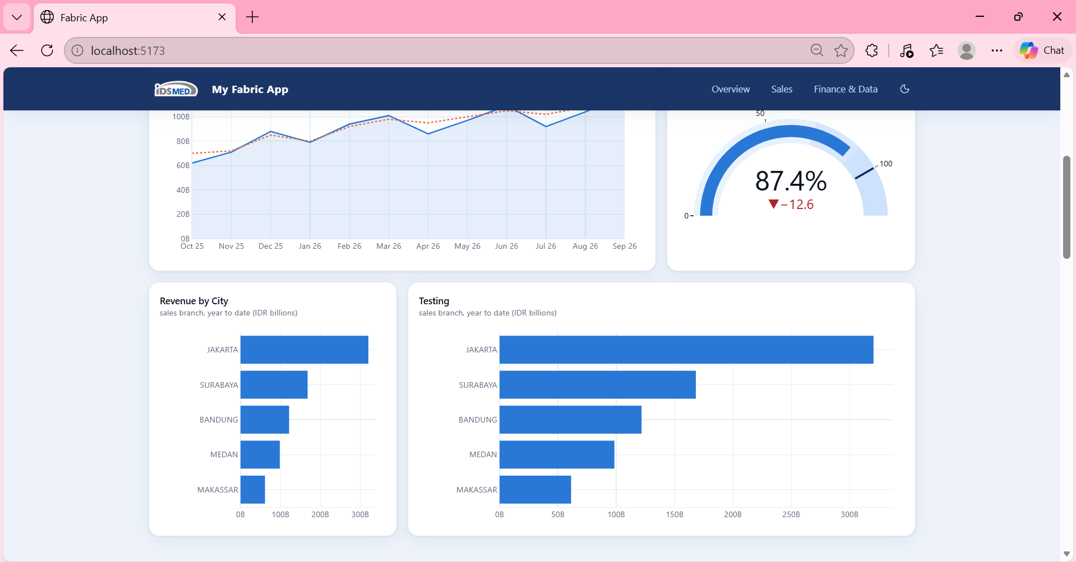
I added Testing Visual and adjust the width of the visual with this code.
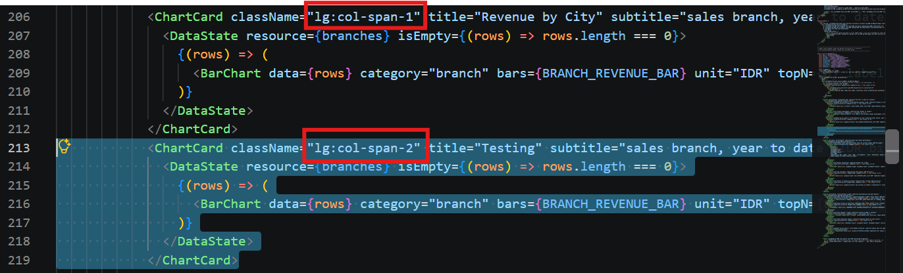

Look at README to see component list table
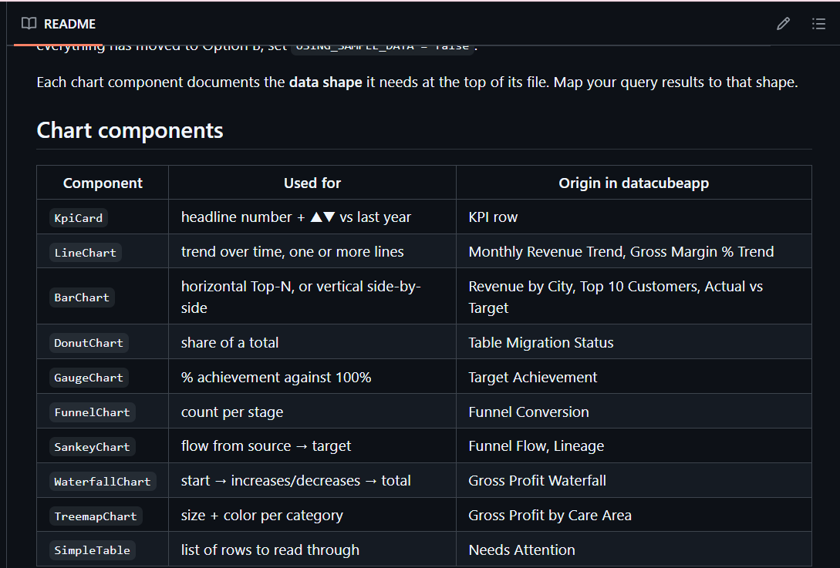

There is always description how to use them at the top of the files.
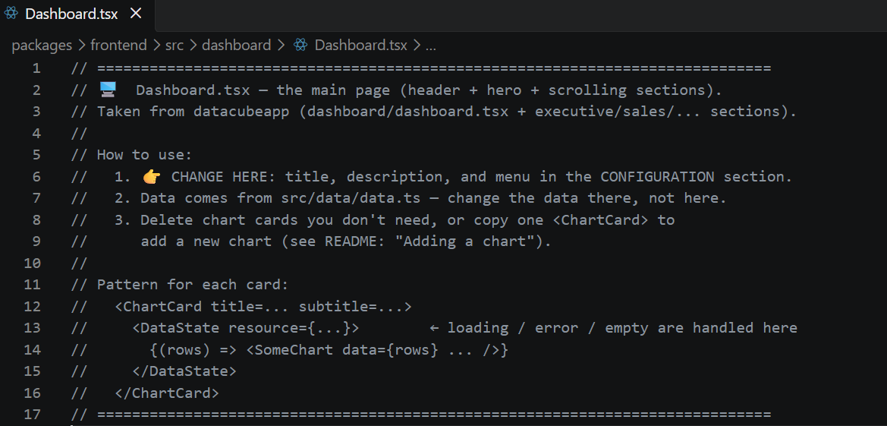

- Search “Change here”, that’s the only part to change
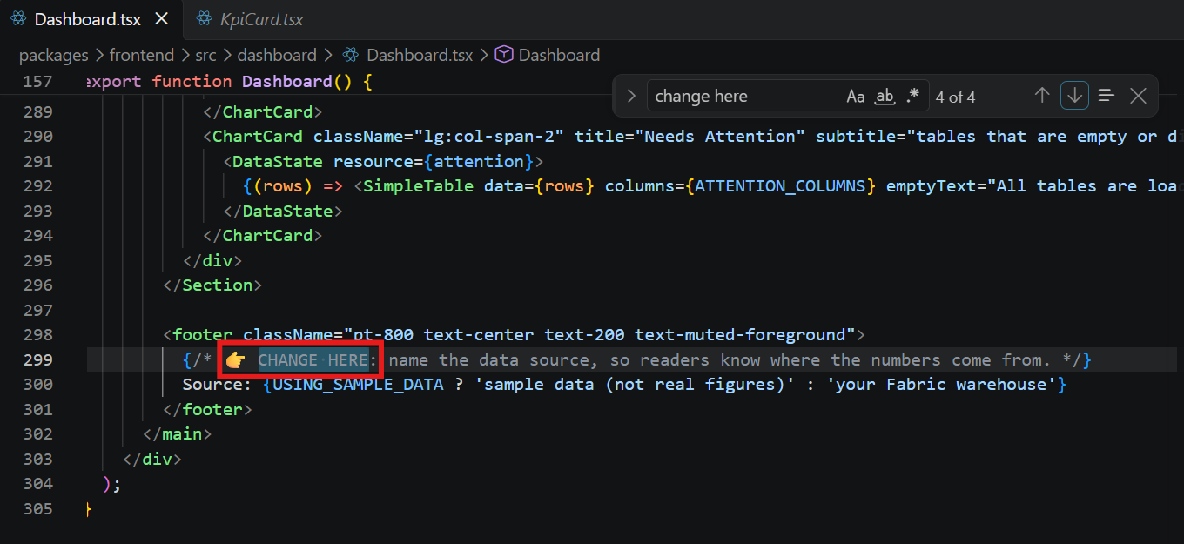

- Need help? Use prompt in PROMPTS_FOR_CLAUDE.md
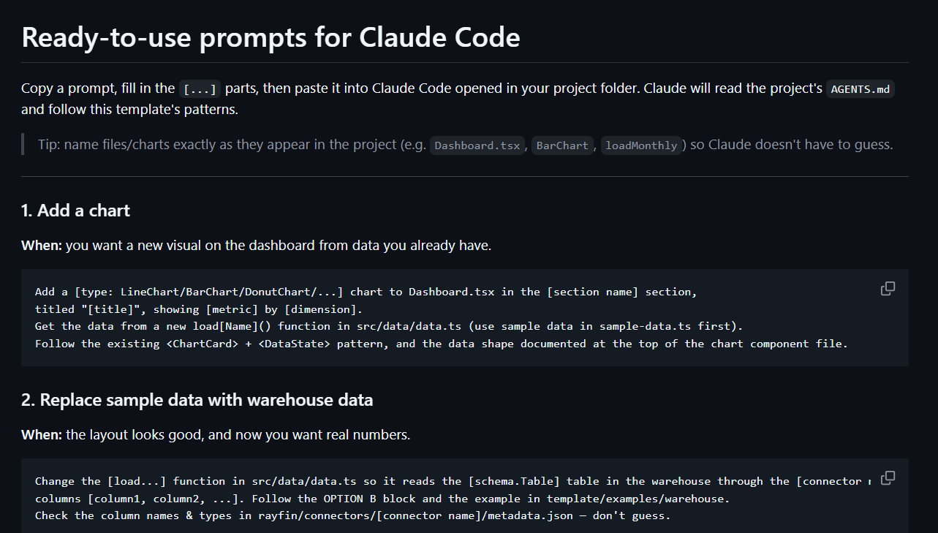

B2. Assign the data by yourself (self-service)
You hold full control: write the query/entity by yourself OR ask AI. Both are supported.
- Principle
All data goes through one file – src/data/data.ts
Chart only draws, data is managed in one place.
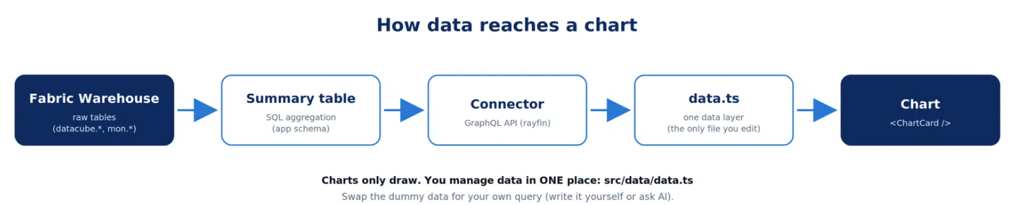

- Method A – sample-data.ts
When to use: trying out the frontend, demo
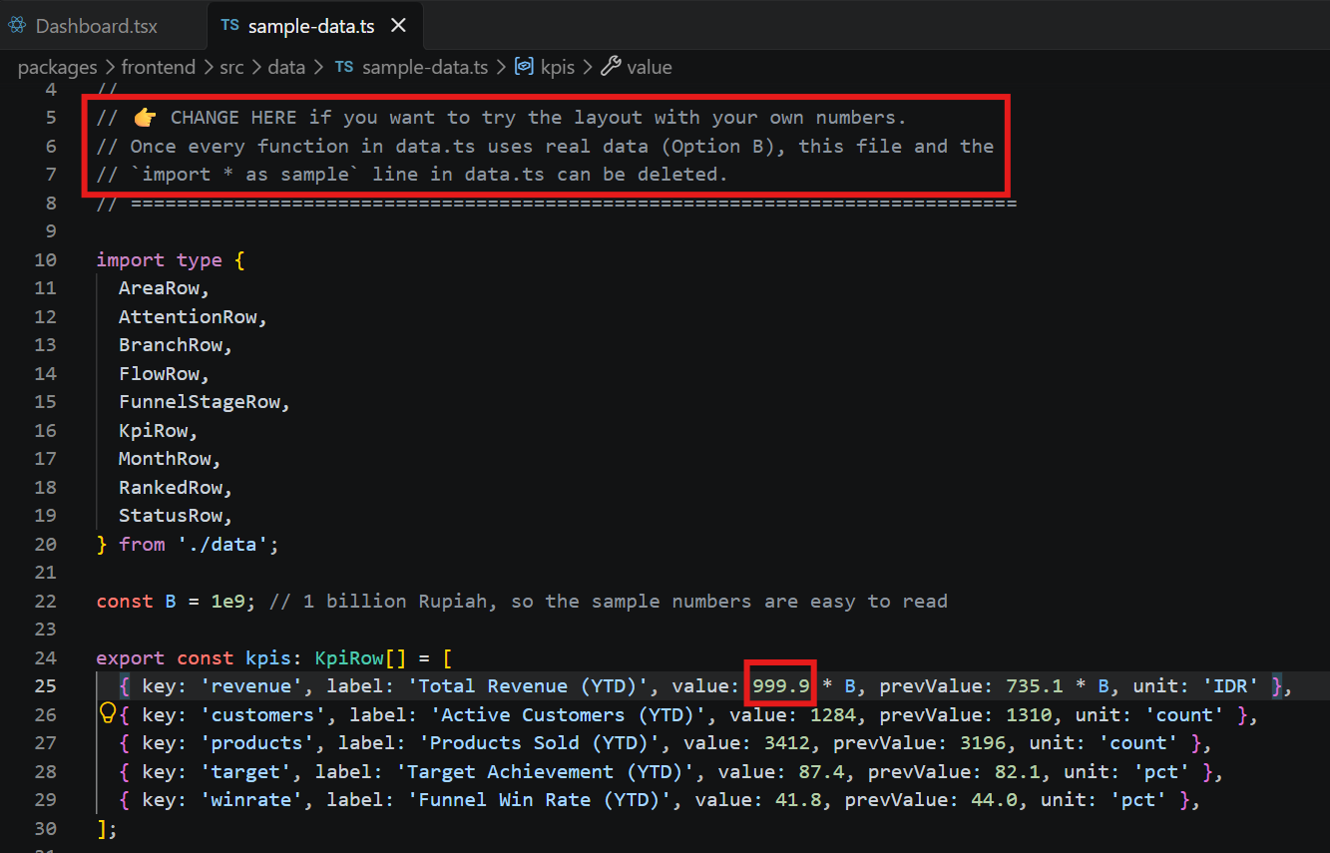
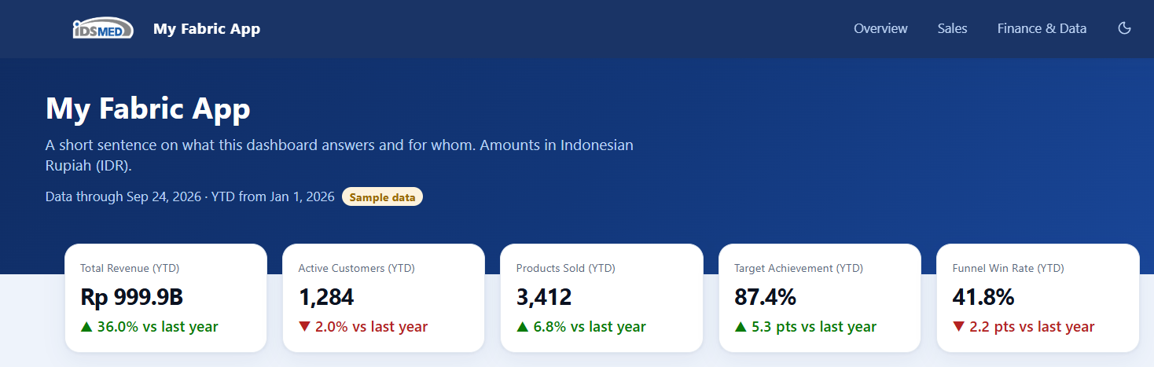

- Method B – warehouse Fabric
Follow the steps in template/examples/warehouse/README.md
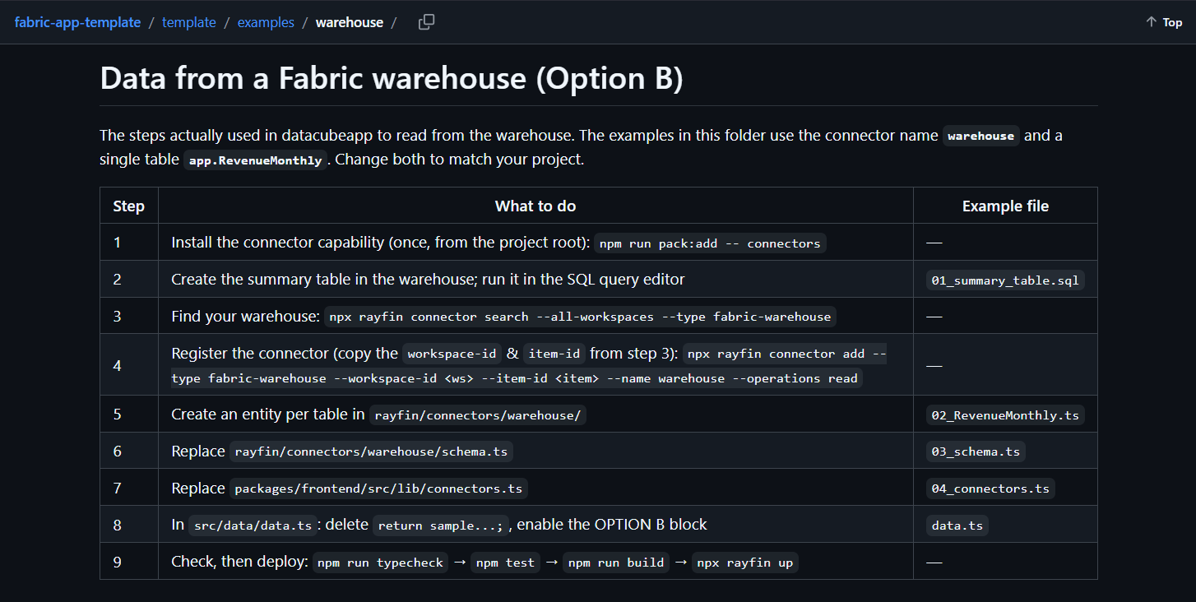

Write SQL as summary table in warehouse (not view). Why? Easy to audit, fast, and not cut off at 100 rows

Register a connector: npx rayfin connector search … → npx rayfin connector add …

Create one entity per table, register it in schema.ts, and wire it up in connectors.ts

Enable the METHOD B block in data.ts, then set USING_SAMPLE_DATA = false

Install connector
Create summary table

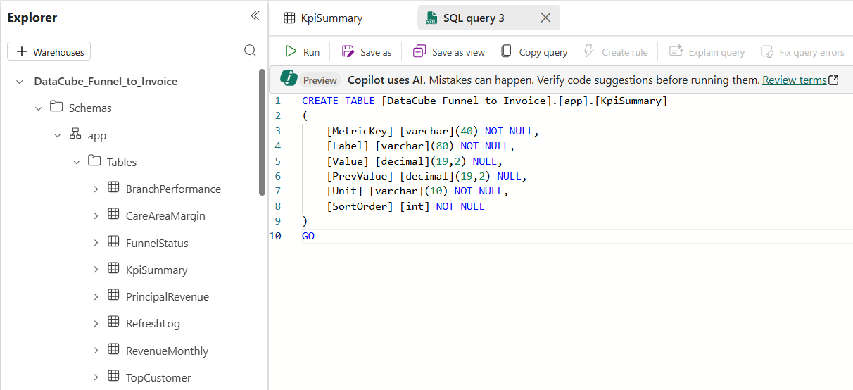
Find your warehouse
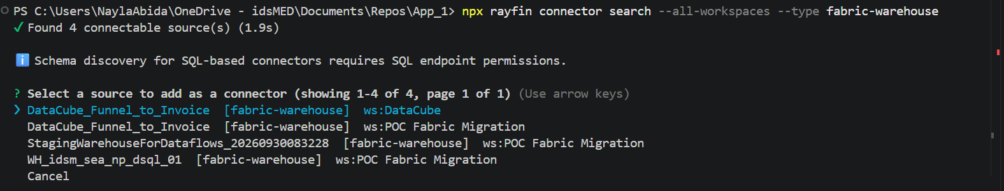
Register the connector
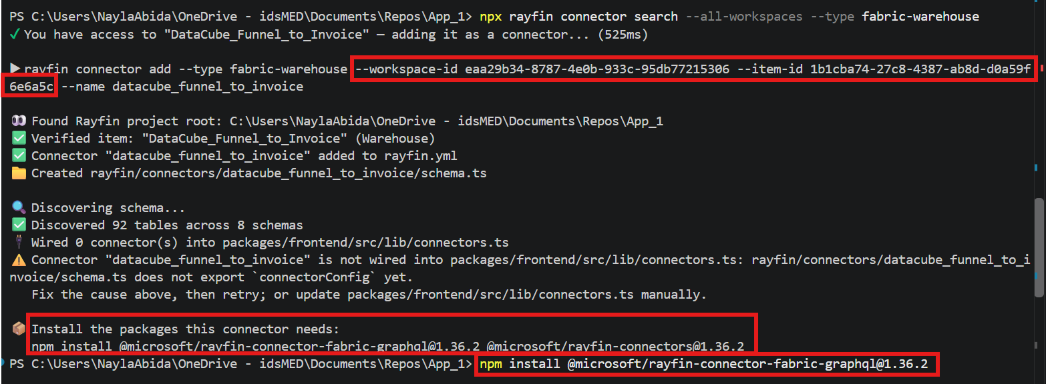
Create an entity table
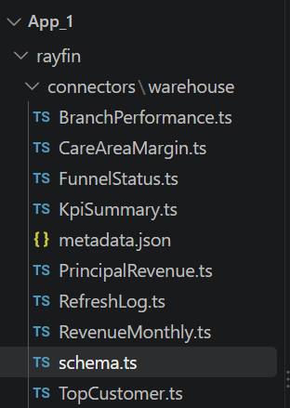
Replace schema.ts and connectors.ts
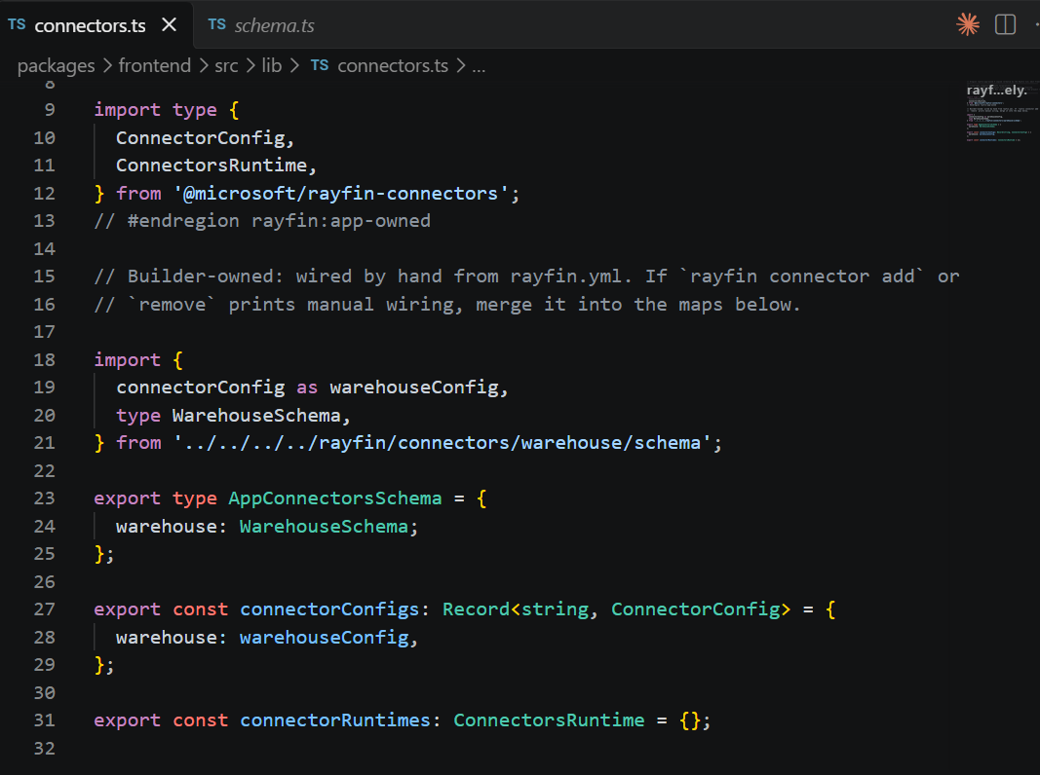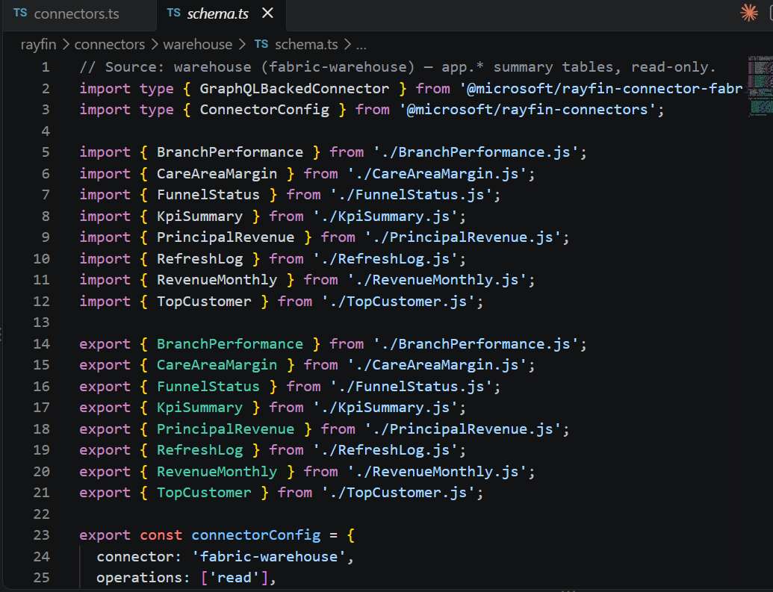
Update data.ts
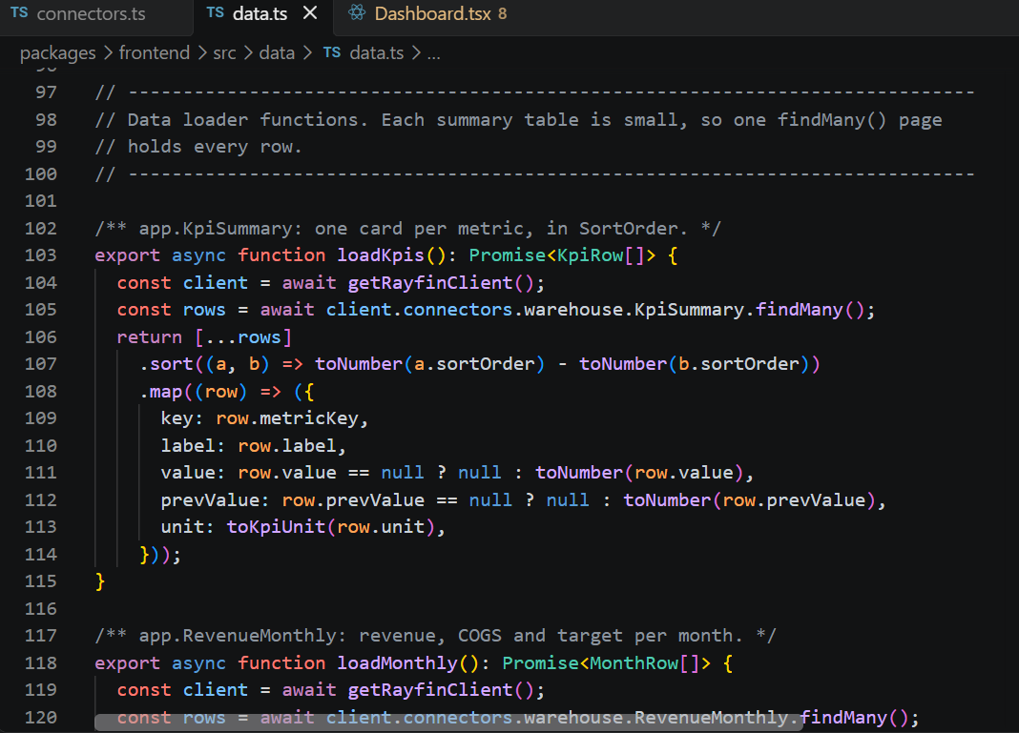
Deploy your app
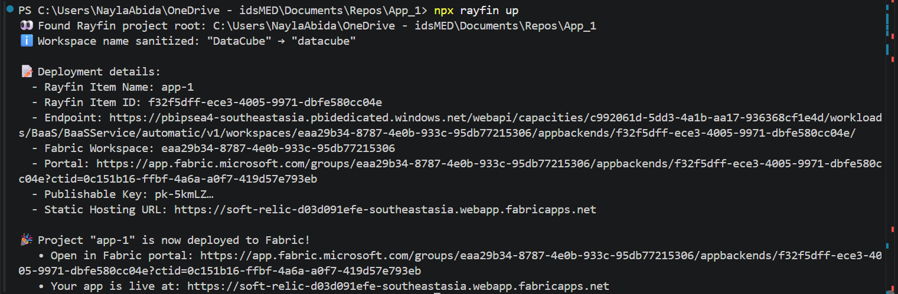

If you can’t write the files by yourself or there are errors, you can always ask AI by copying the error message in the terminal.

- Data type per chart
Every chart states the exact data shape it expects, so you can map your own query to it.

Documented at the top of each components/charts/*.tsx file

Send the raw Rupiah value + `unit="IDR"` → it displays as `Rp 793.9B`
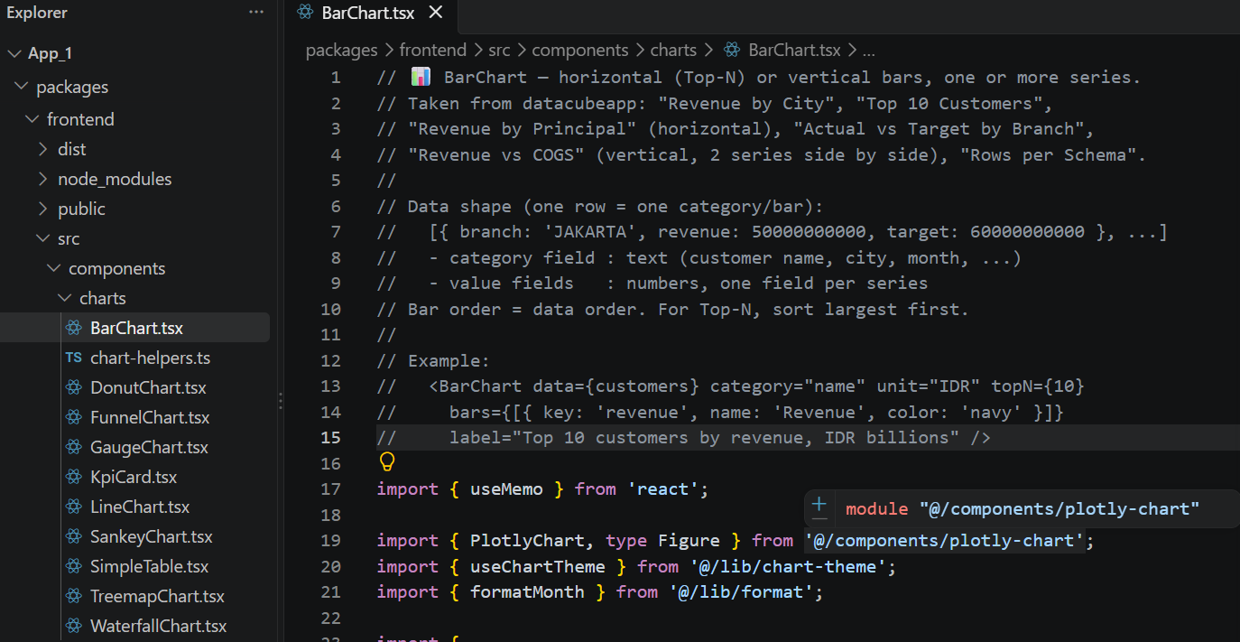

- Add new table/entity
Add a new data source yourself, without being locked to the built-in entities.

Add the table in SQL → a new entity file → 3 lines in schema.ts → a new load...() function

⚠️ Check the column names & types in metadata.json — do not guess

- Scheduling refresh data
Keep the app numbers fresh by re-running the refresh on a schedule.

EXEC app.usp_RefreshAppMetrics; in a Data Pipeline (daily, after the source data has loaded)

Create a new pipeline.
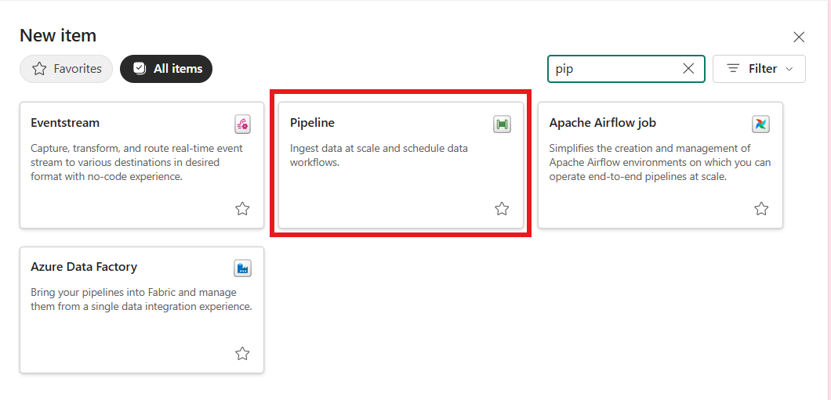
Add new stored procedure activity.
Configure
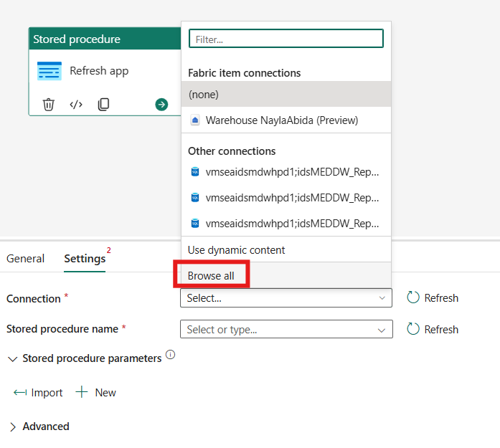
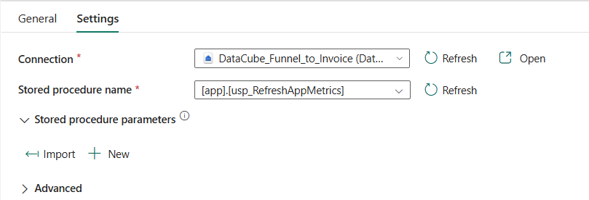
Don’t forget to save.
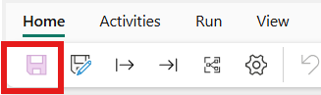
Back to workspace, hover over the pipeline, and click the 3 dots. Select schedule.
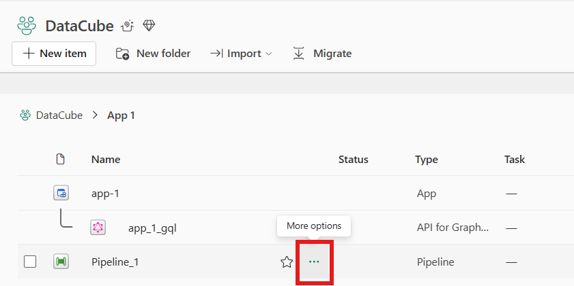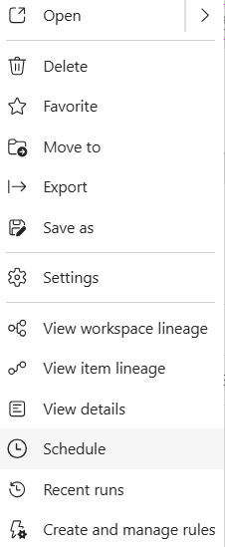
Configure. Don’t forget to save.
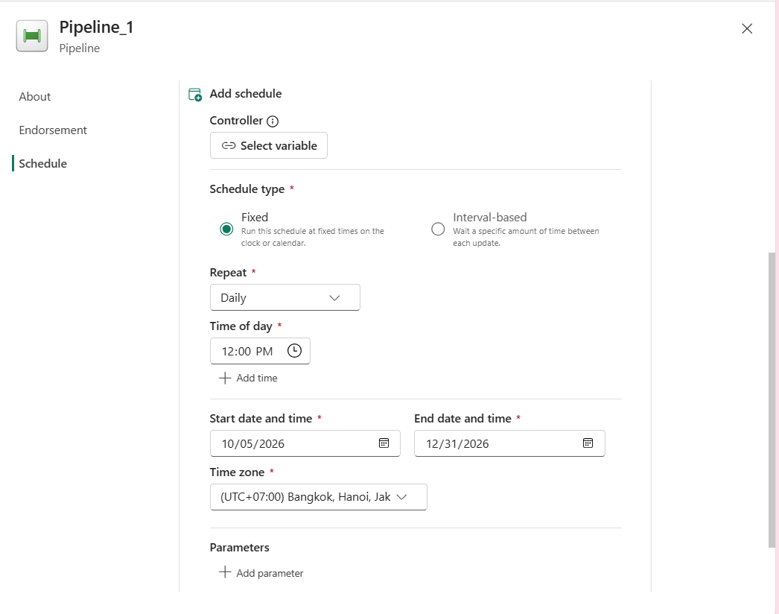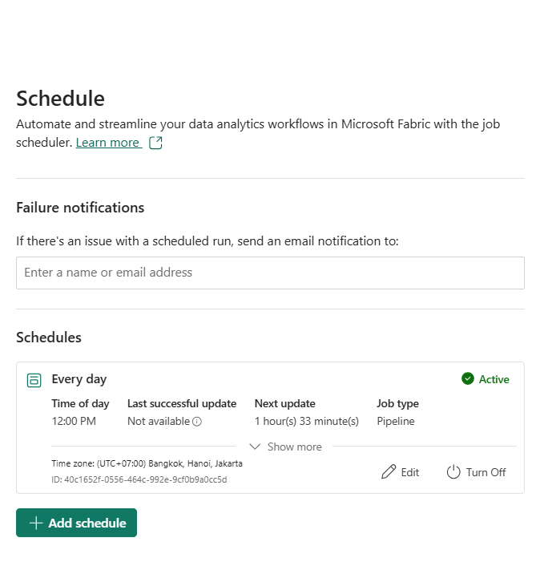

C. Publish & Commit GitHub
- Check before publishing
`npm run typecheck` → `npm test` → `npm run build` (in this order)

- Publish to Fabric — `npx rayfin up`
- Add `--dry-run` to preview the plan without changing anything
- Move / add a target workspace
- `npx rayfin up --workspace "Workspace Name"` → a new deployment
- `npx rayfin up switch --list` / `npx rayfin up switch "<name>"`
- ⚠️ Moving workspace = re-check the connector: the warehouse ID differs even if the name is the same
- Save to GitHub
- `git init` (once) → `git add .` → `git commit -m "message"` → `git remote add origin <url>` → `git push -u origin main`
- ⚠️ Never commit `rayfin/.env`, `.env*`, or `node_modules` — they are already in `.gitignore`
- After every major changes you made, don’t forget to commit for version control by: `git add .` → `git commit -m "message"` → `git push`

- Rollback (return to a previous version)
- Undo one commit: `git revert <commit>` then `npx rayfin up`
- View history: `git log --oneline`
- Try an old version without changing history: `git checkout <commit>` → `npx rayfin up` → `git checkout main`
- Note: `rayfin up switch` **changes the target workspace**, it is not a rollback

D. Data Agent
- Create a data agent in the workspace — + New item → Data agent
Prerequisites: Contributor role; the Copilot/Data agent feature enabled in the tenant
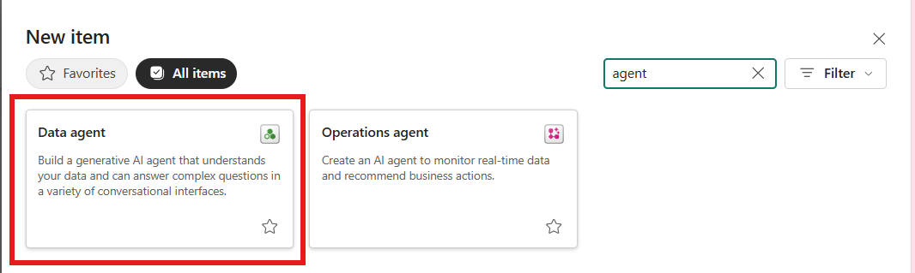

- Choose the data source
- The same warehouse as the app; tick **only** the tables you need
- Prefer summary tables (their numbers match the dashboard) plus detail tables as needed
- ⚠️ Avoid GUID columns (`uniqueidentifier`) — not readable via the SQL endpoint; join on the text code columns instead
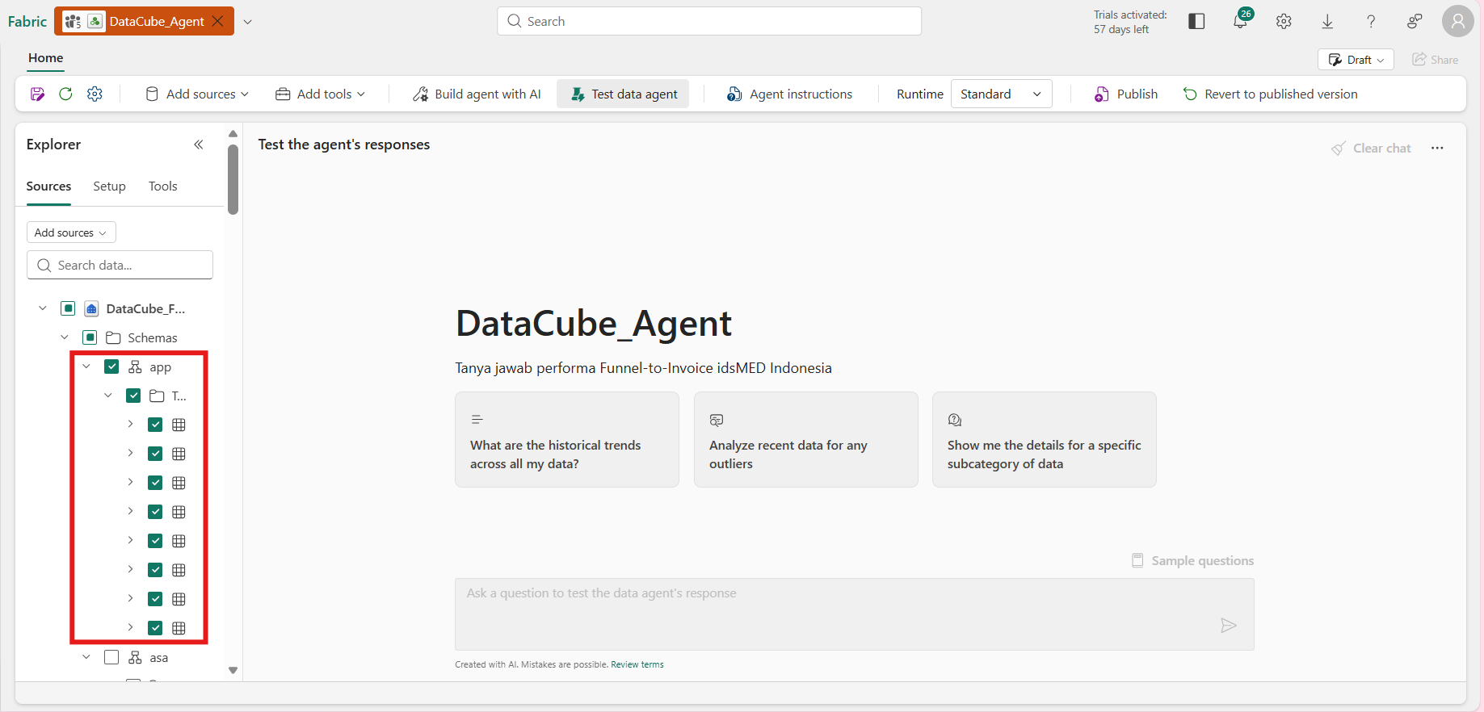

- Agent instructions
- Include: role, answer language, data scope (mandatory filters), business definitions, SQL rules
- ⚠️ Write ALL instructions in the desired answer language — mixed-language instructions make the agent follow the dominant language
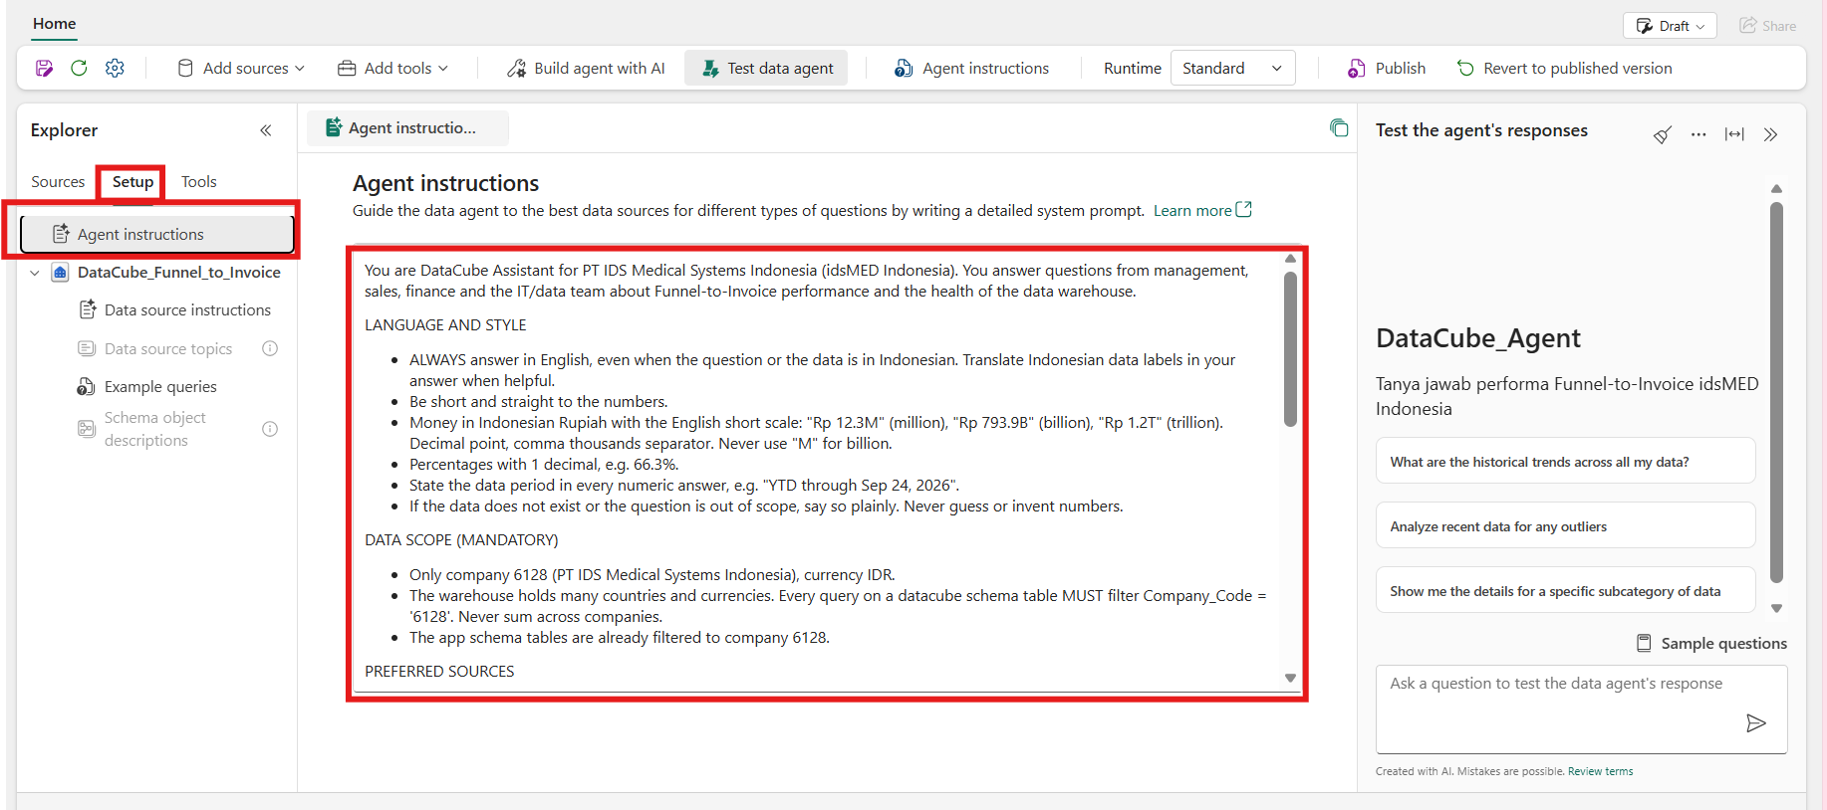
- Data source instructions — explain the contents of each table & its important columns
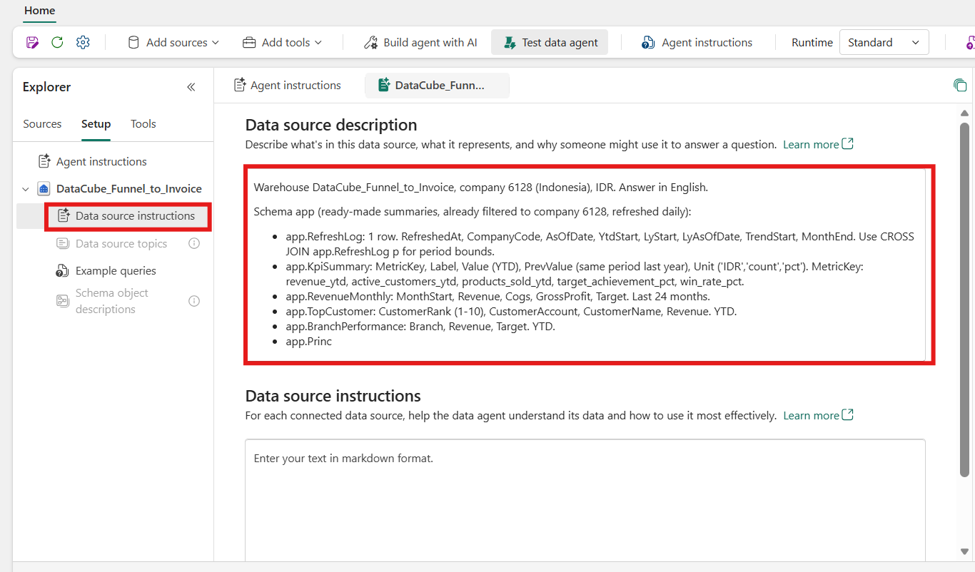
- Example queries — question + correct-SQL pairs
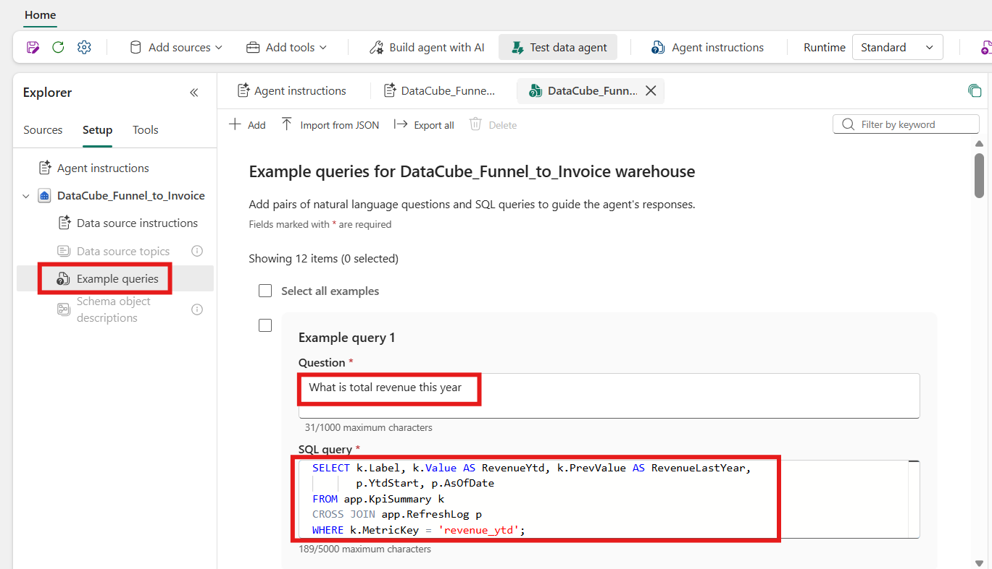

- Test in the chat panel
- Compare answers with the dashboard numbers; open "Show SQL" and check the filters
- Test out-of-scope questions — the agent should refuse
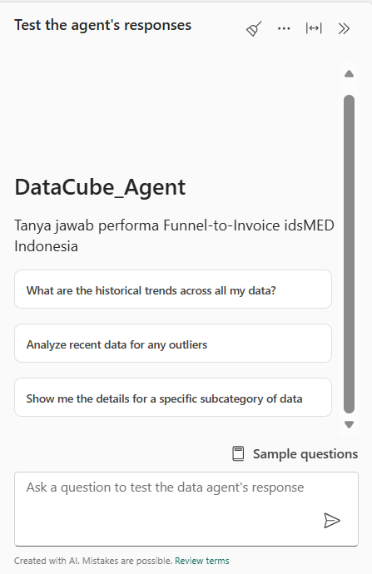
- Publish
- ⚠️ Every time you change the instructions → Publish again; the app uses the published version, not the draft
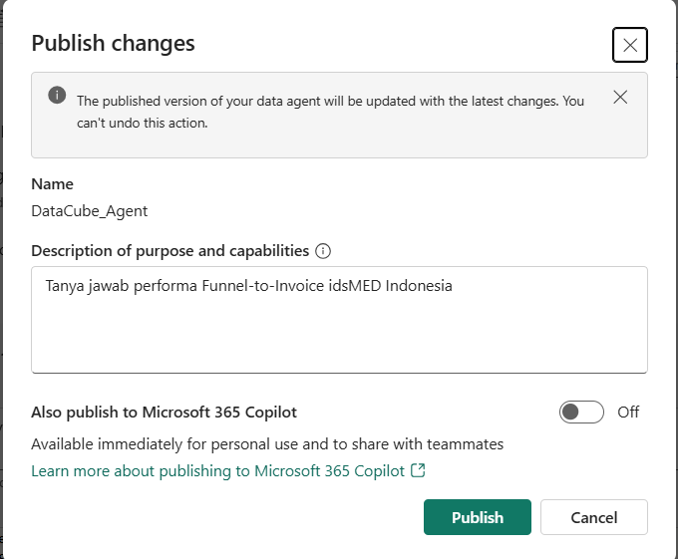
- Copy the MCP endpoint:
https://api.fabric.microsoft.com/v1/mcp/workspaces/<ws>/dataagents/<id>/agent

- (Advanced) Integrate into the app
- Via a function running server-side (the `functions` capability), so the Fabric token never reaches the browser
- The function calls the agent on behalf of the app item owner (the account that deployed it) → app users do not each need agent access, but everyone queries with the owner permissions
- Function time limit in Fabric: 250 seconds
- TODO: architecture explanation + reference to datacubeapp (`packages/functions/src/function_app.ts`)

Troubleshooting
Symptom | Cause | Fix
No connectors are declared in project settings | npm run dev strips connectors from the backend (CLI 1.36.0) | Run npx rayfin up. For local work, use npm run dev:frontend.
All charts fail even though some tables exist | One entity in schema.ts is missing in the warehouse or is a view | Create the missing table or remove the entity from schema.ts.
“The summary table is not available yet” | The summary table is not created or the connector is not deployed | Run the SQL in the warehouse, then npx rayfin up.
“You do not have permission…” | The account/app has no access to the warehouse | Ask the workspace admin for access.
App numbers do not change | The refresh procedure has not run or is not scheduled | Run EXEC app.usp_RefreshAppMetrics; and set up a Data Pipeline.
Error 15816: “not supported in distributed processing mode” | INSERT … SELECT reads the system catalog (sys.*) | Read the catalog into a text variable first, then INSERT using dynamic SQL.
Build/typecheck error: “declared but its value is never read” | A sample-data import is no longer used after moving to Method B | Delete the import line indicated by the error.
Test fails looking for “Your app is taking shape” | The default Root.spec.tsx / App.spec.tsx have not been replaced | Copy App.spec.tsx and Root.spec.tsx from the template.
Data Agent answers in the wrong language | Instructions use mixed languages or have not been re-published | Use a single language for the instructions, then Publish.

